**OBJECT ORIENTED PROGRAMMING**

**PROJECT REPORT**

**Student Registration Management**

**Class: BSCS - 2C**

**Group Members:**

1. **Abdul Arham (2312192)**
2. **Abdullah Azhar (2312193)**
3. **Abeer Fayyaz (2312194)**

**Submitted to: “Sir Humair Bughio”**

**Introduction**

Our project, Student Registration Management, is all about making it easier for schools to handle student registrations. This is super important because it helps schools run smoothly and makes sure students get the classes they need.

**Motivation**

We decided to work on this project because traditional registration processes in schools are often messy and slow. There's too much paperwork, mistakes happen, and it takes forever to get things done. We wanted to fix that by creating a system that makes registration faster and simpler for everyone.

**Scope**

Our system does a lot of cool stuff. It lets students register for classes online, helps administrators manage courses and student records, and makes communication between everyone involved a lot easier. It's designed to work for all kinds of schools and can be customized to fit their specific needs.

**Methodology**

We started by talking to a bunch of people to figure out what they needed from a registration system. Then we used modern technology to build the system, making sure it's easy to use and can handle lots of students and courses. We tested everything to make sure it works well and then helped schools set it up and start using it.

"Student Registration Management" employs a modular architecture, segregating presentation, business logic, and data access layers. It utilizes standard Java package structures and integrates with JDBC for database connectivity, ensuring efficient data interaction. The GUI features multiple components like Frames. Panels, labels, text fields, and buttons for an intuitive user experience. Seamless page navigation is facilitated by well-defined workflows. The development process follows Agile methodologies and employs Swing for GUI development, along with JDBC for database interaction, showcasing key functionalities with code snippets and relevant graphical illustrations.

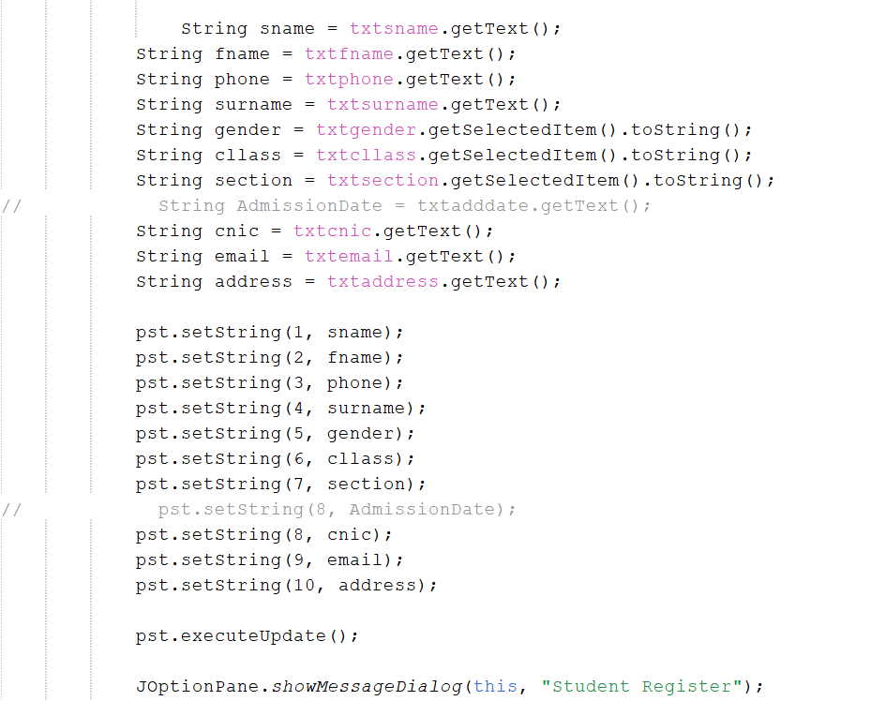

**Conclusion**

Our Student Registration Management project has made a big difference in how schools handle registrations. It's made things faster, simpler, and more organized for both students and administrators. We're excited about the future of this project and how it can continue to improve registration processes in schools.

Top of Form